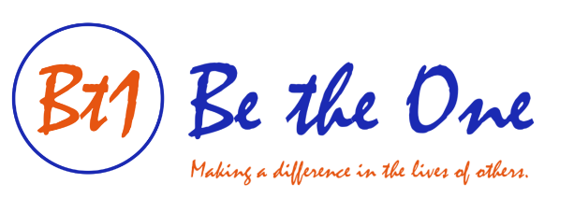

Fourth Annual Four-Person Scramble Golf Tournament
St. Anne’s Country Club, Feeding Hills, MA
July 17, 2022 Light Lunch at 12:00 pm Shotgun Start at 1:00 pm

Event participation includes light lunch, player gifts, 18 holes of scramble golf, cart, on course contests, buffet dinner, and more!! Great raffle prizes!! Dinner only option available as well!! Visit www.bt1person.org for registration forms and sponsorship information.

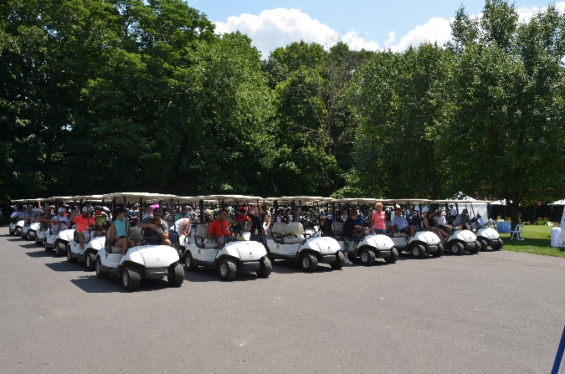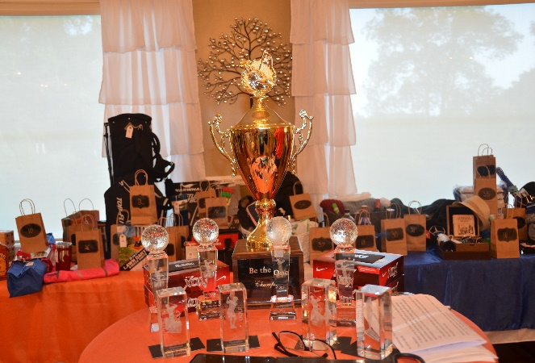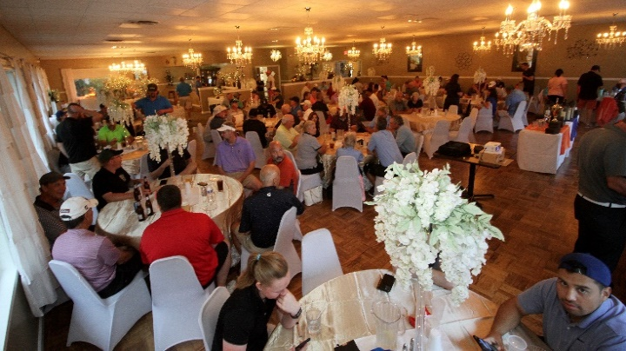

To see register for the event, see more photos from our past tournaments, and to learn more about our organization, visit our website at www.bt1person.org

We look forward to seeing you soon! In the meantime, please keep doing what you’re doing. Every day, we all have the chance to Be the One to make a difference in the lives of others!

Be the One Foundation, Inc., P.O. Box 346, Enfield, CT 06083-0346
www.bt1person.org

